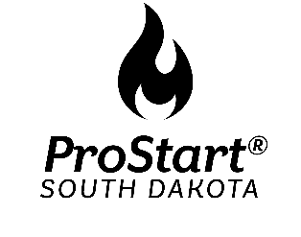
2023 SD ProStart Student Invitational Decorated Cake Competition

THEME: Throwback 90’s

Eligibility:
All high school students previously or currently enrolled in a program using the ProStart curriculum. One team may represent an individual school in Decorated Cakes. A team consists of 1 or 2 members.

Purpose:
Participating students will demonstrate their skills, knowledge, and creative ability.

Cake Decorating Competition:
- The base of the cake can be no bigger than 18”x 24” and be no higher than 3 feet and can incorporate any shape.
- The cake may be layered; frosting or filling and/or pillars or dividers may be used between layers to support the theme and decoration.
- Form pans cannot be used for the main theme of the cake, i.e. you cannot use a Mickey Mouse form pan to make a Mickey Mouse cake.

What to Bring:
- One cake, and all items for decorating, i.e. filling, frosting, ganache, rolled fondant, and other edible decorations, in the theme.
- Six (6) identical copies of the following stapled in left upper corner and placed in a manila envelope with your school name on front:
  - Cover page with school name, student baker(s) and a photo of the finished cake.
  - Costing and recipe forms containing the school name, the name(s) of the student baker(s), the exact recipes and food costs with the recipe source. Use Culinary Competition costing/recipe/menu forms. Please note that the cake recipe must include information on frosting, filling, and any edible decorations. Menu price should equal cost for the entire cake, not by serving size.
  - One to two paragraphs describing the relationship of their original cake decoration to the theme.
  - Certification page signed by instructor. (Attachment A)
  - Photo(s) of finished cake (2-4 photos on one page)
- Framed Description for Team Kitchen includes:
  - School name
  - Name(s) of the student baker(s)
  - Photo of team and their finished cake
- Decorative items can be made from premade materials like gum paste, marzipan, fondant, sugared flowers, chocolate molded pieces or edible papers. The student must provide the form Attachment A, signed by their ProStart instructor stating that the premade edible decorations were made by the student in the instructor’s presence.
- Students cannot use manufactured decorations, not made by themselves on their cake.
- Fondant to cover cakes must be made by students.
- Team will display piping skills during cake decorating competition. See rules below in Production.

Check In: The check in time will be determined once all the registrations are in and your team will be notified. Any team that does not report during the assigned check in will be disqualified. The only exception will be late arrival due to unforeseen circumstances such as weather. In such case, the bakers and their teacher/coach should notify the State Coordinator, as soon as possible to make alternate arrangements.

Team Kitchen: The workspace will consist of two (2) eight-foot tables provided for each team. The tables will be set up in an “L” formation within a 10’x10’ space. All preparation must be done within the workspace on the tables provided. All equipment and supplies must be contained within the allotted space. Teams will be provided one speed rack, but must bring their own sheet pans. NO BURNERS/STOVES are allowed for this competition.

Competition:
- Teams will have ten (10) minutes to set up their kitchen and prepare for the piping skills segment.
- During the piping skills segment teams will have ten (10) minutes to present two (2) of the five (5) skills listed below. Teams must bring colored buttercream frosting, bags and tips for this portion of the competition. Students will perform the piping on disposable white cake boards provided by team. Your skills selected for each team member will be at your team kitchen the day of competition. (See Attachment B for pictures of piping techniques)
        - Shell Border
        - Reverse Shell Border
        - Basket Weave (3 weave high)
        - Puff Garland
        - Handwriting (first name)
- Teams will have sixty (60) minutes to assemble and decorate their cake.
- Teams are allowed to bring cakes, pre-filled, and crumb coated only. (Ask instructors)
- Teams will present cakes to judges at team kitchen and provide tasting. Judges will have opportunity for Q & A during this time.
- Teams will have ten (10) minutes to clean their team kitchen.
- Teams will receive their critique at the team kitchen prior to end of competition time. Instructors are allowed to be present during this critique.
- Teams will exit the team kitchen and place their team cake on the display table located in the conference lobby.

Points: Total points for the cake rubric will be 90.

Dress: The students will also be judged on professional appearance and demeanor. Preferred attire is white chef coats, hats, dark pants, and closed toe, hard sole shoes. Event staff will provide aprons and hats to teams.

Disqualification:
Teams may be disqualified for any of the following reasons:

1. Failure to check-in during the specified time.

2. Failure to bring to the event any of the required items (one cake with the chosen theme, and six (6) copies of the required documentation).

3. Bringing to the event food that has been transported and/or stored so that items could have been exposed to bacteria. Examples would be bread not in sealed containers, frostings and cakes not in sealed containers and/or not stored at proper temperature for ingredients.

4. Determination by the judges that the student bakers received assistance in preparation, baking, and decorating their items.

5. Misconduct, which includes any non-prescription drug, alcohol, or tobacco use or unprofessional, unsportsmanlike conduct at the event, during the competition or in activities or locations related to the event. Should any misconduct come to SD ProStart Coordinator’s attention, the matter will be investigated, as the SD ProStart Coordinator deems appropriate. Any decision and sanction as to appropriate action due to misconduct is at the sole discretion of the SD ProStart Coordinator and is final. By entering the competition, the student and the school they represent agree to accept this requirement as well as other conditions of the Invitational.

In the Case of a Tie:
If teams are tied, the team with the highest Product Taste score will be chosen as the winning team in each category. If that is a tie then the team in each category with the highest score in Product Appearance will be the winner.

Questions contact—Seanna Regynski, ProStart Coordinator, at sregynski@sdra.org , or call 605.224.5050.

Decorated Cake Scoresheet Judge:___________________________
Name of School:________________________________________________
Team Members:________________________________________________
 | 1-2 | 3-5 | 6-8 | 9-10 | POINTS
Documentation/ Recipe & Costing | Plan not provided | Documents inadequate, hard to understand, not well-labeled, not followed | Documents complete, neat enough to follow. , but not followed completely | Documents complete, easy to read, followed completely
Theme | Does not follow theme. | Some of the design can be interpreted to go with theme. | Theme easily identified. | Creative interpretation of theme. Clever and appealing. Unique
Icing | Areas of cake are not iced and there are crumbs. | Uneven or not level. | Spread evenly, but lacks some evenness and consistency. | Spread evenly, Smoothly finished. Is even and consistent
Decorations | No decorations | Inappropriate size, unpleasing color scheme. | Appropriate for theme, but too large or small for cake. Too many or not enough. Unpleasing color scheme. | Appropriate for size of cake. Skill mastery evident. Appropriate size and amount for size of cake. Colors enhance design
Level of difficulty | Cake design and decorations are simplistic, no tips used | Cake design/ decorations display a few skills, only one tip is used. | Cake design and decorations display moderate skills, at least two tips were used. Work is not precise | Use of at least two decorating tips. Difficulty level is high. Work is neat and precise.
Taste & Consistency | Cake is not appealing | Cake needs many improvements to be ready for customer | Cake needs just a few improvements to be ready for customer | Cake is appealing
Piping Skills  (overall score for both teammates) | Piping needs many improvements | Piping needs improvements | Piping could use a few improvements | Piping is excellent
Sanitation & Safety | Unsafe food handling, personal hygiene, and improper storage Display area is messy | Basic skills in safe food handling and personal hygiene. Display area is messy. | Sanitation procedures followed: temperature control, hand/equipment sanitation. Display area messy. | All possible sanitation procedures followed: temperature control, hand/equipment sanitation. Display area clean
Participant Appearance & Participation | Clothing is not suitable for professional / team does not interact with judges | Some aspects of professional clothing / team marginally interacts with judges | Most aspects of professional clothing / team interacts with judges | Dressed professionally: chef coat, head covering, apron, closed-toe shoes / team fully interacts with judges
Total: /90
Comments:

ProStart Cake Decorating
Confirmation of Student Participation

School Name: _____________________________________________________________

I __________________________ (Instructors Name) verify that ___________________ (student baker) and __________________________ (student baker) completed all aspects of this project on their own, under my supervision.

Instructor Signature ___________________________________ Date ________________

Attachment A

Judge Piping Skills Sheet

Teams must bring colored buttercream frosting, bags and tips for this portion of the competition. Students will perform the piping on disposable white cake boards provided by team.

1. Shell Boarder
2. Reverse Shell Boarder
3. Basket Weave (3 weave high)
4. Puff Garland
5. Handwriting (first name)

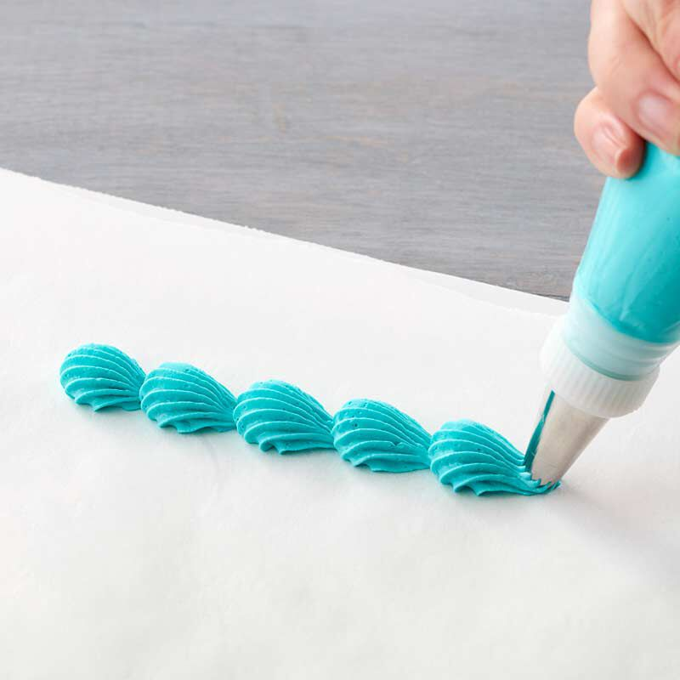
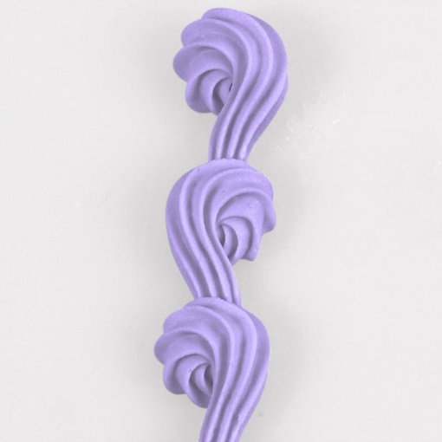
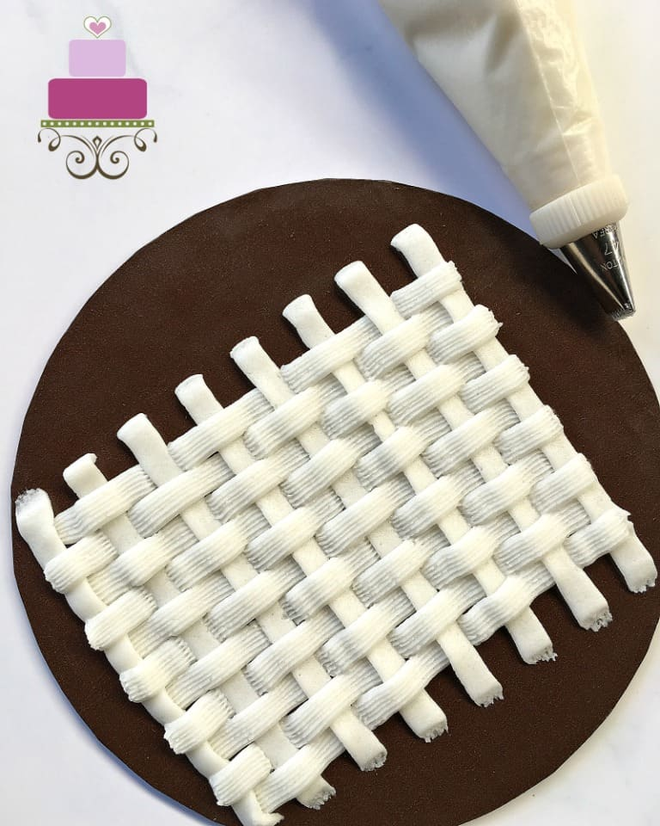
Shell Boarder
Reverse Shell Boarder
Basket Weave
Puff Garland
Handwriting

Attachment B

